The design for Meet-Meet is made up of several individual components. The first component will by a Graphical User Interface (GUI) that the user will interact with. The second component will be the Android code (written in c#) that will run on a user’s device. Finally, we will create a backend with a database to store user data in the long term. To help us meet these goals we will be using a program called Xamarin to compile c# code and provide a GUI builder. We will also be attempting to use the free service tier of Amazon Web Services (AWS) to host our server and database. Our application must be able to access the user’s location and use that to match them with other users in the same area. Thus, it is essential that we be able to efficiently find a user’s location, as well as easily finding users of the same area. Furthermore, we need to find a way to group users together and allow the grouped entity to interact with other users/groups.

The most important aspect of Meet-Meet is the location based grouping. This will be the backbone of our application and it is imperative that it works properly. Our application will attempt to present users of our app with the profiles of other users in the area. This will allow the user to view the interests on the other profile and will let them contact the other user through the app. Contact will either be done as a messaging service through the app itself, or it will merely push a notification to the other user’s device and if that user agrees, the application will distribute the phone numbers of the two users to each other (In this scenario, no information will change hands until both user’s consent). Once a group has been formed, one user must be designated as the leader, this will either happen in an automatic, random way through the app, or the users may designate a leader themselves. Once a group has been formed and a leader has been designated, that new group will act in the same manner as an individual, and the application will allow the group to enter the grouping “pool” again and make more matches.

The information of a user’s profile will be stored in a database, this information will be retrieved from the user’s Android device using the getLastLocation() method of the Google Play services. This location will be stored within a database which also contains the user’s profile information. The matching of locations will be determined by database queries using a specific radius around the user’s current location.

At our current time, we will be attempting to use Amazon Web Service’s (AWS) free service tier to host our server side operations. We will use this to store user information in a database which we will be able to pull from to suite our needs. The design of the database will be basic, as none of us have much experience with databases. We will store custom information about a user including their name, phone number, username/email, a random number specific to the user to be used for salting the password hash, and finally, a hashed version of their password + salt. In addition to custom information, we will require the user to choose one or more options from pre-determined lists in the following categories: Interests and Languages.

C:\Users\Chris\Downloads\Untitled Diagram(1).png

Example user database table

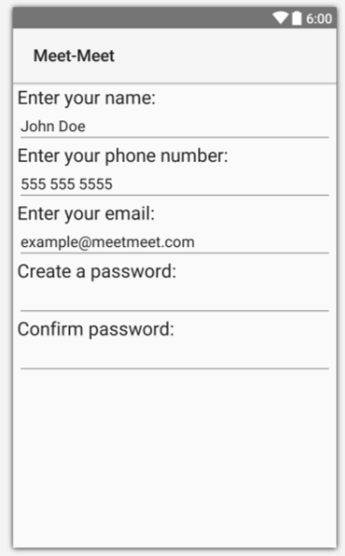

Example user sign up gui

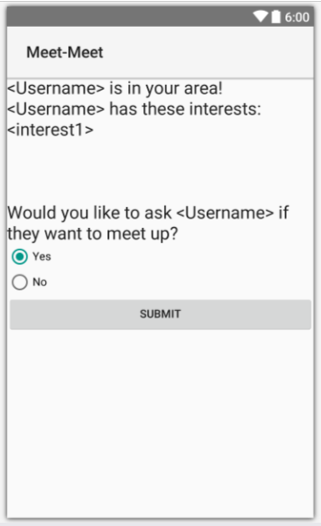

Example match gui